Jenkins Deployment Troubleshooting

*Issue 1:-*

System has not been booted with systemd as init system (PID 1). Can't operate. Failed to connect to bus: Host is down

1. sudo nano /etc/wsl.conf

2. Add this to the wsl.conf file:

[boot]

systemd=true

Save the file (CTRL + X, then Y, then Enter).

3.Open Command prompt:-

wsl –version

wsl --update

wsl.exe --shutdown

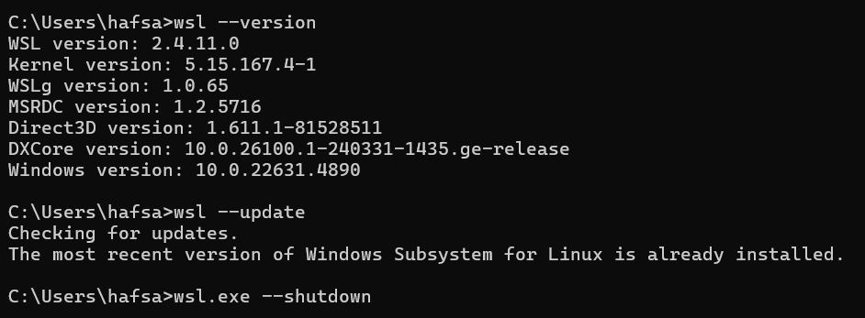

*Issue 2:-*

error: externally-managed-environment × This environment is externally managed ╰─> To install Python packages system-wide, try apt install

*Replace install_python_packages() function with the following code:-*

install_python_packages() {

print_section "INSTALLING PYTHON AND REQUIRED PACKAGES"

# Check if Python is installed

if command -v python3 &> /dev/null; then

python_version=$(python3 --version)

print_success "Python is already installed: $python_version"

else

print_warning "Python 3 is not installed. Installing Python 3..."

sudo apt-get update

sudo apt-get install -y python3 python3-pip python3-venv

# Verify installation

if command -v python3 &> /dev/null; then

python_version=$(python3 --version)

print_success "Python installed successfully: $python_version"

else

print_error "Failed to install Python. Please install it manually."

exit 1

fi

fi

# Create a virtual environment

print_warning "Creating a virtual environment..."

python3 -m venv ~/my_python_env

source ~/my_python_env/bin/activate

# Install required Python packages inside the virtual environment

print_warning "Installing required Python packages..."

pip install python-jenkins

print_success "Python packages installed successfully"

# Deactivate virtual environment

deactivate

}

*In ubuntu:-*

sudo systemctl status jenkins

sudo systemctl start jenkins

./jenkins-setup-script.sh

*Key learnings:-*

[boot]

systemd=true

This enables systemd inside Windows Subsystem for Linux (WSL)

Enabling systemd allows you to use services (systemctl, journalctl, etc.).

**Allows Running Background Services** – Services like Jenkins, Docker, MySQL, and others depend on systemd. Enabling this lets them function properly.

